**PROJECT – 4**

**PROJECT NAME :**  **TIC TAC TOE GAME**

**NAME OF THE STUDENT : DERANGULA ANKITHA**

**DATE OF THE PROJECT : 1-08-2023**

**PROJECT SUMMARY :**

In the Tic-Tac-Toe game, you will see the approach of the game is implemented. In this game, two players will be played and you have one print board on the screen where from 1 to 9 number will be displayed or you can say it box number. Now, you have to choose X or O for the specific box number. For example, if you have to select any number then for X or O will be shown on the print board, and turn for next will be there. The task is to create a Java program to implement a 3×3 Tic-Tac-Toe game for two players.

How to Play the Game :

* Both the players choose either X or O to mark their cells.
* There will be a 3×3 grid with numbers assigned to each of the 9 cells.
* The player who choose X begins to play first.
* He enters the cell number where he wishes to place X.
* Now, both O and X play alternatively until any one of the two wins.
* Winning criteria: Whenever any of the two players has fully filled one row/ column/ diagonal with his symbol (X/ O), he wins and the game ends.
* If neither of the two players wins, the game is said to have ended in a draw.

**INPUT :**

**package SourceCode;**

**import javax.swing.*;**

**import java.awt.*;**

**import java.awt.event.*;**

**import java.util.Random;**

**public class TicTacToeGame implements ActionListener {**

**Random random=new Random();**

**JFrame frame=new JFrame();**

**JButton buttons[]=new JButton[9];**

**JLabel textfield=new JLabel();**

**JPanel Heading_Panel=new JPanel();**

**JPanel Button_Panel=new JPanel();**

**boolean player1_turn=true;**

**TicTacToeGame(){**

**//Frame**

**frame.setVisible(true);**

**frame.setSize(800,800);**

**frame.getContentPane().setBackground(new Color(50,50,50));**

**frame.setLayout(new BorderLayout());**

**//Heading**

**textfield.setFont(new Font("Ink Free",Font.BOLD,40));**

**textfield.setBackground(new Color(25,25,25));**

**textfield.setForeground(new Color(25,255,0));**

**textfield.setHorizontalAlignment(JLabel.CENTER);**

**textfield. setText("TIC-TAC GAME");**

**textfield.setOpaque(true);**

**//Heading panel**

**Heading_Panel.setLayout(new BorderLayout());**

**Heading_Panel.setBounds(0,0,800,100);**

**Heading_Panel.add(textfield);**

**frame.add(Heading_Panel,BorderLayout.NORTH);**

**//Button pannel**

**Button_Panel.setLayout(new GridLayout(3,3));**

**Button_Panel.setBackground(new Color(150,150,150));**

**for(int i=0;i<9;i++){**

**buttons[i]=new JButton();**

**buttons[i].addActionListener(this);**

**buttons[i].setFont(new Font("MV Boli",Font.BOLD,100));**

**Button_Panel.add(buttons[i]);**

**}**

**frame.add(Button_Panel);**

**firstTurn();**

**}**

**public void actionPerformed(ActionEvent e){**

**for (int i=0;i<9;i++){**

**if (e.getSource()==buttons[i]){**

**if(player1_turn){ //true X turn**

**if (buttons[i].getText()==""){**

**buttons[i].setForeground(new Color(255,0,0));**

**buttons[i].setText("X");**

**player1_turn=false;**

**textfield.setText("O TURN");**

**check(); //calling check function**

**}**

**}**

**else{ //O turn false**

**if (buttons[i].getText()==""){**

**buttons[i].setForeground(new Color(0,0,255));**

**buttons[i].setText("O");**

**player1_turn=true;**

**textfield.setText("X TURN");**

**check(); //calling check function**

**}**

**}**

**}**

**}**

**}**

**public void check() {**

**//X Win Conditions**

**if(buttons[0].getText()=="X" && buttons[1].getText()=="X" && buttons[2].getText()=="X"){**

**XWin(0,1,2); // calling XWin Function**

**}**

**if(buttons[3].getText()=="X" && buttons[4].getText()=="X" && buttons[5].getText()=="X"){**

**XWin(3,4,5); // calling XWin Function**

**}**

**if(buttons[6].getText()=="X" && buttons[7].getText()=="X" && buttons[8].getText()=="X"){**

**XWin(6,7,8); // calling XWin Function**

**}**

**if(buttons[0].getText()=="X" && buttons[3].getText()=="X" && buttons[6].getText()=="X"){**

**XWin(0,3,6); // calling XWin Function**

**}**

**if(buttons[1].getText()=="X" && buttons[4].getText()=="X" && buttons[7].getText()=="X"){**

**XWin(1,4,7); // calling XWin Function**

**}**

**if(buttons[2].getText()=="X" && buttons[5].getText()=="X" && buttons[8].getText()=="X"){**

**XWin(2,5,8); // calling XWin Function**

**}**

**if(buttons[0].getText()=="X" && buttons[4].getText()=="X" && buttons[8].getText()=="X"){**

**XWin(0,4,8); // calling XWin Function**

**}**

**if(buttons[2].getText()=="X" && buttons[4].getText()=="X" && buttons[6].getText()=="X"){**

**XWin(2,4,6); // calling XWin Function**

**}**

**// O Win Conditions**

**if(buttons[0].getText()=="O" && buttons[1].getText()=="O" && buttons[2].getText()=="O"){**

**OWin(0,1,2); // calling OWin Function**

**}**

**if(buttons[3].getText()=="O" && buttons[4].getText()=="O" && buttons[5].getText()=="O"){**

**OWin(3,4,5); // calling OWin Function**

**}**

**if(buttons[6].getText()=="O" && buttons[7].getText()=="O" && buttons[8].getText()=="O"){**

**OWin(6,7,8); // calling OWin Function**

**}**

**if(buttons[0].getText()=="O" && buttons[3].getText()=="O" && buttons[6].getText()=="O"){**

**OWin(0,3,6); // calling OWin Function**

**}**

**if(buttons[1].getText()=="O" && buttons[4].getText()=="O" && buttons[7].getText()=="O"){**

**OWin(1,4,7); // calling OWin Function**

**}**

**if(buttons[2].getText()=="O" && buttons[5].getText()=="O" && buttons[8].getText()=="O"){**

**OWin(2,5,8); // calling OWin Function**

**}**

**if(buttons[0].getText()=="O" && buttons[4].getText()=="O" && buttons[8].getText()=="O"){**

**OWin(0,4,8); // calling OWin Function**

**}**

**if(buttons[2].getText()=="O" && buttons[4].getText()=="O" && buttons[6].getText()=="O"){**

**OWin(2,4,6); // calling OWin Function**

**}**

**}**

**private void XWin(int a, int b, int c) {**

**buttons[a].setBackground(Color.GREEN);**

**buttons[b].setBackground(Color.GREEN);**

**buttons[c].setBackground(Color.GREEN);**

**for(int i=0;i<9;i++){**

**buttons[i].setEnabled(false); //Disable the buttons after win**

**}**

**textfield.setText("!! Congratulations, X Wins");**

**}**

**public void OWin(int a, int b, int c){**

**buttons[a].setBackground(Color.GREEN);**

**buttons[b].setBackground(Color.GREEN);**

**buttons[c].setBackground(Color.GREEN);**

**for(int i=0;i<9;i++){**

**buttons[i].setEnabled(false); //Disable the buttons after win**

**}**

**textfield.setText("!! Congratulations, O Wins");**

**}**

**public void firstTurn(){**

**try {**

**Thread.sleep(2000);**

**} catch(Exception e){**

**e.printStackTrace();**

**}**

**if(random.nextInt(2)==0){**

**player1_turn=true;**

**textfield.setText("X TURN");**

**}**

**else{**

**textfield.setText("O TURN");**

**}**

**}**

**public static void main(String[] args){**

**// TODO Auto-generated method stub**

**new TicTacToeGame();**

**}**

**}**

**OUTPUT:** 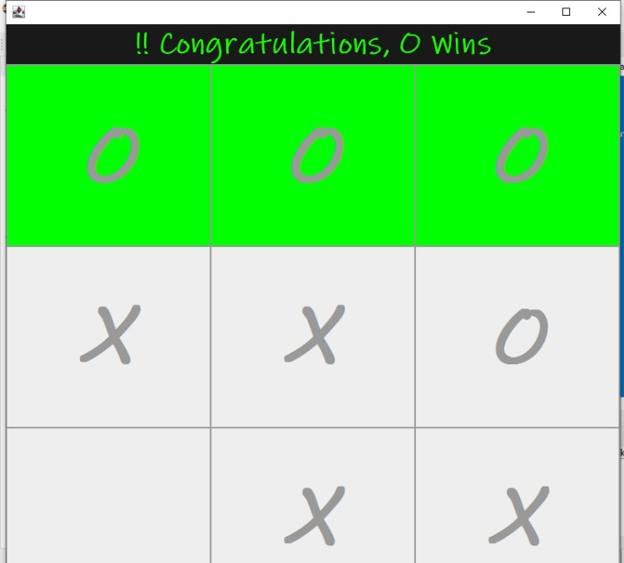

Project by D.Ankitha